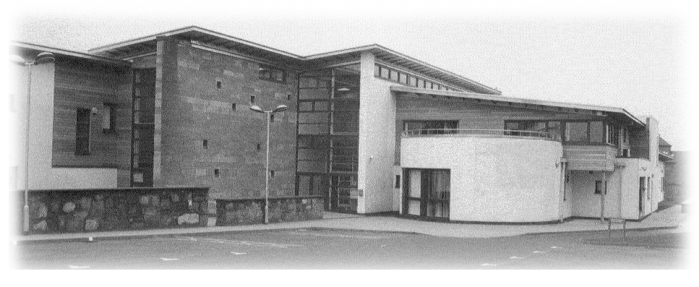Dr Giles Ledlie West Practice

Dr Andrew Forrester Springfield Medical Centre

Dr Craig Nicoll 30 Ponderlaw St

Dr Raquel Romero-Perez Arbroath

Dr Helen Webb DD11 1ES

Dr Katherine Murnal Tel 01241 870307

Medical Receptionist Vacancy (30 hours per week)

Thank you for your enquiry regarding our Medical Receptionist vacancy.

We are seeking to recruit an enthusiastic and versatile receptionist to join our team working in a busy but fulfilling environment.

You will be working in a busy environment and we are looking for applicants who are enthusiastic about providing the best service for our patients.

Ideally applicants will have a good standard of general education, excellent communication skills, excellent multi-tasking skills, experience working with the public and good IT knowledge. You must be reliable, organised and a team player. Previous experience of Vision, Docman and medical terminology will be an advantage but full training will be given for the right candidate.

Hours for the post will be:

Monday 8am – 4pm
Tuesday 8am – 4pm
Wednesday 8am – 4pm
Friday 10am - 6pm

It is essential to be flexible as additional hours may be required from time to time.

We hope to hold interviews middle of May 2026 or sooner if we find the right candidate. If you have not heard from us by the end of May 2026 please assume that you have been unsuccessful on this occasion.

Yours sincerely

Gemma Kirkpatrick
Practice Manager

